CHAPTER 1: Introduction to Knowledge Graphs

*Google Knowledge Graph*: in the past if you searched “places to visit in LA” the Google search engine would simply return a ranked list of webpages, then the user could put together the answers to their original question. Now it is possible to interpret the query (richiesta) more deeply, now Google KB provides directly a list of places to visit in LA. In many cases it may not even be necessary to click on a webpage like.

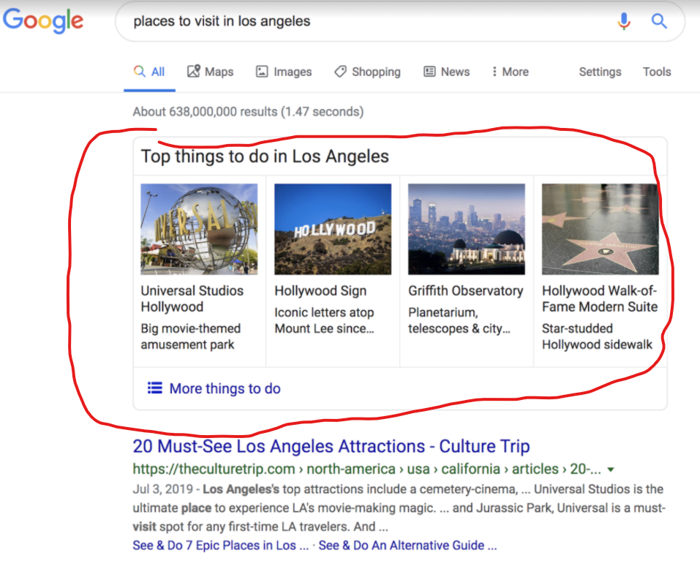

If I search *Taj Mahal* it can be ambiguous it can denotes

* The monument in India
* A local restaurant in any number of cities
* A casino in Atlantic City (New Jersey)

Depending on where (which part of the globe) the search is done one result might be more influenced than others. Also focus on the immediate search history of the user. If no context is available then external information (other people search histories…) could be useful.

## 1.5 Concluding Notes

A KG is a practical and machine-readable way of representing information about the world, including entities, relationships, attributes, facts, beliefs and even provenance (origini/provenienza) including justifications and uncertainty.